Spatial optimization of the afforestation zoning of agricultural land to estimate the carbon sequestration potential under the food security restriction in Beijing, China

**Abstract:** In order to increase the carbon sequestration as well as improve the air quality, the afforestation of agricultural land is considered as a practical method for Beijing, China. Due to the balancing of the need of crop land to support the food security of population, it is still challenging to allocate the afforestation area and estimate the carbon holding capacity of agricultural afforestation. The spatial heterogeneity of both the food productivity and carbon holding capacity, and the objective pursuit of spatial compactness further complicated this problem. The spatial optimization of afforestation area of agricultural land is a multi-objective wherein the spatial heterogeneity and compactness need to be considered. In this research, we proposed a particle swarm optimization (PSO) model to address this issue and estimate the carbon holding capacity of agricultural afforestation in Beijing, China. The model was simulated with multi scenarios of different food decrease rates and the spatial compactness weights. Results demonstrated that 1) both the pursuit of food security and the spatial compactness would affect the optimized distribution of afforestation area and do negative effect on the carbon sequestration potential; 2) the pursuit of spatial compactness would do less effect on the optimized carbon holding capacity when the food decrease rate is high than it is low; 3) 8.80 -12.47 Tg C (14.82 – 20.93 % of the maximum carbon sequestration potential with different spatial compactness weight settings) can be sequestrated with 5% loss of current food productivity in the optimization results; 4) the PSO model can be used to solve the spatial optimization problem of agricultural afforestation under the consideration of spatial heterogeneity, spatial compactness and food security. This research can also contribute to the implication of artificial intelligence method on land use planning.

**Keywords:** Afforestation, Agricultural land, PSO, Beijing

# 1 Introduction

Following with the rapid population growth and industrial revolution, CO2 emissions have increased by 90% from 1970 to 2011 (IPCC Climate Change, 2014). The greenhouse effect is accelerated due to the concentration increase of carbon dioxide in atmosphere and lead to the global warming. Climate change problems are caused by global warming and the offset of carbon dioxide from atmosphere to terrestrial system is becoming one of the most important issues both for science research and human activity.

Besides the carbon emission from fossil fuel consumptions, which contributes to 80% of the global total emissions (Andres et al., 2011), land use change of deforestation to agricultural land (Woodwell et al., 1983) and farm operations (R. Lal, 2004) also plays important role in both global and regional carbon emissions. The greenhouse emission from global agriculture are increasing at around 1% per annum (IPCC Climate Change, 2014). The potential of emission reduction and carbon sequestration of agricultural land with recommended management practices (RMP) is huge (Rattan Lal, 2004; Morari et al., 2006) but also acute because of the limited achievable reductions from changing farming (Franks and Hadingham, 2012) and the conflict with food productivity (Tilman et al., 2011).

Despite the RMP, the afforestation of agricultural land is always an alternative approach to mitigate the climate change (Kane and Solutions, 2015; Niu and Duiker, 2006), or the most favorable way to meet the commitments of carbon reduction (Falloon et al., 2002). The annual carbon sequestration rates of above- and blow-ground biomass after afforestation are estimated as 0.4-1.2 Mg C ha-1 yr-1 in boreal regions, 1.5-4.5 Mg C ha-1 yr-1 in temperate regions, and 4-8 Mg C ha-1 yr-1 in tropical regions (Noble et al., 2000). Although the effects of afforestation on SOC are varied in soil properties, climate regions, revegetation types, etc. (Zeng et al., 2014), most research reveals that the topsoil carbon (<30 cm) will generally decrease during the earlier years of afforestation and then increase during the later year (Chang et al., 2014; Laganière et al., 2010; Nave et al., 2013; Shi et al., 2015). Recent research has also revealed that the soil C/N is the most factor determining the SOC sequestration rates of afforestation (Deng et al., 2016). Meanwhile, the amounts of SOC change after afforestation are generally small compared with the carbon accumulation of biomass (Paul et al., 2002). Besides the carbon accumulation, afforestation can also generate additional environmental benefits, such as improving the air quality, reducing the soil erosion, and enhancing wildlife habitat (Plantinga and Wu, 2003). Especially in Beijing, agricultural afforestation can not only play important role in the carbon sequestration but also be an efficiency method to improve the air quality in this region (Beyer, 2006; Yang et al., 2005). Farmers are also willing to convert the arable land out of agricultural and get allowance form government due to the little profit of agricultural activity and the high return of non-agricultural works (Chenfang et al., 2002). Although the agricultural afforestation is a win-win approach for both farmers and environment, balancing the need of arable cropland is still the major restriction of agricultural afforestation program (Nilsson and Schopfhauser, 1995; Xu et al., 2006). The high quality of arable land and the fully constructed agricultural facilities make it more important balancing the food productivity and carbon sequestration function of agricultural land in this region.

Similar to other land use optimization problems, the spatial optimization of afforestation area under the restriction of food security is a multi-objective problem wherein the spatial heterogeneity and spatial compactness should be considered (Liu et al., 2015; Zhou, 2015). The particle swarm model (PSO), an AI-based method developed based on the social behavior of bird flocking or fish schooling (Eberhart and Kennedy, 1995) , has been widely used in the spatial optimization of rural land use allocation (YaoLin Liu et al., 2012), urban land-use planning (Liu et al., 2013; Masoomi et al., 2013), and land use zoning problems (Yaolin Liu et al., 2012). All these applications show that the PSO is feasible to achieve the optimal solution of multi-objective problems through the competition and cooperation among particle of the swarm. While the proper setting of population size of particles, cognitive and social acceleration constants, the inertia weights, and maximum iterations can result in the fast convergence and alleviation of local optimal (Parsopoulos and Vrahatis, 2007), the adaptive function and the iteration mechanism are key technics in the formulation of PSO in particular problems.

The main objective of this study is to simulate the optimization afforestation area and estimate the SOC sequestration potential of afforestation under different scenarios of food security and spatial compactness weights in Beijing. The comparison of different scenarios will also be conducted to reveal the relationship among the pursuits of different objectives. In the following parts of the paper, we will give a brief instruction of the study area and data resources first. In the method part, we will first estimate the food productivity of agricultural land and the carbon sequestration potential of agricultural afforestation with 1km *1km grids, respectively. Then we will describe the formulation of PSO to simulate the optimization of agricultural afforestation under different scenarios of food decrease rates and spatial compactness weights. In the results part, we will show the simulation results of multi-scenarios and analyze the effects of food security and spatial compactness on the distribution of afforestation area and the carbon sequestration potential of the optimization results. Finally, we will make a discussion and conclusion of this research.

# 2 Study area and data material

Beijing, the capital of China, is northeastern China at the northern tip of the North China Plain. The geography in this region is characterized by alluvial plain in the south and east, and mountains and hills in the north and west (Wu et al., 2006).The average annual temperature ranges from 9.76 ℃ to 13.42 ℃, and the average annual precipitation from 424 mm to 628 mm. According to the land use map interpreted from remote sensing data (Jiyuan et al., 2002),the total area of Beijing is 16,420 km2. The area of agricultural land is 4,087 km2, 25% of the total area. The area of forest land is 7,309 km2, 45% of the total area. The agricultural land is mainly distributed in the south and east of this area, and the forest is mainly distributed in the north and west of the area (Figure 1). As it was proposed in the latest urban planning of Beijing city (<http://zhengwu.beijing.gov.cn/gh/dt/t1494703.htm>), Beijing is attend to increase the forest area to increase the ecological value and build the forest city in the next two decades. The increase of forest area will mainly come from the afforestation of agricultural land and built-up land.

The afforestation program has a long history in Beijing and the total afforestation area from 1978 to 2015 reaches 9947 km2 with an average annual afforestation of 262 km2. Meanwhile, the food crop cultivation area has decreased from 5,610 km2 to 1,040 km2 and the food productivity has decreased from 1860 Mg to 626 Mg in the same period, although the food productivity ability has increased from 0.33 Mg/ha to 6.02 Mg/ha (<http://www.bjstats.gov.cn/nj/main/2016-tjnj/zk/indexch.htm>) in the same time. The decrease of food cultivation area comes from both the urbanization and afforestation processes of agricultural land.

The land use data of Beijing, 2015 is provided by Data Center for Resources and Environmental Sciences, Chinese Academy of Sciences (RESDC) (<http://www.resdc.cn>). The data was interpreted from Landsat TM images, and the overall accuracy of 81%. The format of the database is grid with a spatial resolution of 100 m * 100 m (Figure 1). The spatial distribution data of the average annual temperature and precipitation come from the Kriging interpolation results based on the meteorological stations recordings for the last two decades (http://data.cma.cn/). The soil map and properties, including soil bulk density, SOC density, soil clay content, and pH, come from the China Soil Map (Nachtergaele et al., 2009), obtained from the Cold and Arid Regions Sciences Data Center at Lanzhou (<http://westdc.westgis.ac.cn>). The data was developed based on the Second National Soil Survey of China, which was conducted from the late 1970s to the early 1990s.

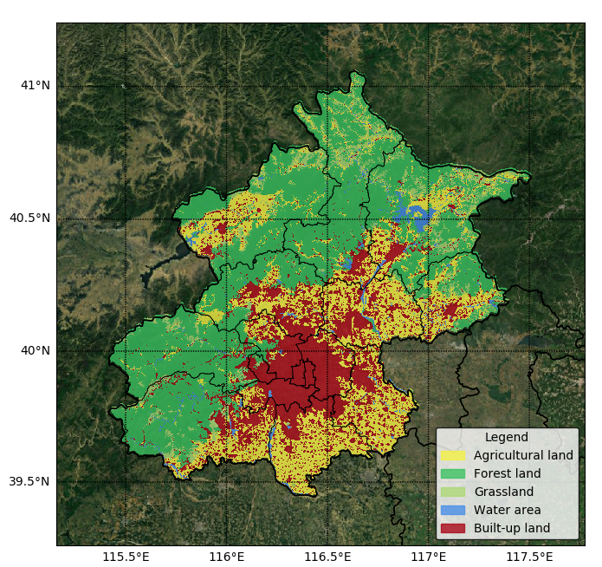

Figure 1 Land use map of Beijing, 2015

# 3 Methods and results

## 3.1 Food crop productivity estimating

Food crop productivity of 1km * 1km grids were estimated based on the Global Agro-ecological Zones (GAEZ) (Fischer et al., 2012, 2002) model and land use maps of Beijing, 2015 (100 m * 100 m) (Eq. 1).

(1)

whererepresents land use grids of 100 * 100m in the zoning grid of 1km * 1km; represents the food cultivation ratio which can be calculated from the statistical book (table 1). represents the food production capacity of the grid estimated by the GAEZ model. In the GAEZ model, we selected maize as the crop type and calculated the aggregate potential productivity based on the soil and slope distribution on the one hand, and crop, environment and management specific fallow period requirements on the other hand (Fischer et al., 2012).

Table 1 Food cultivation ratio of different counties in Beijing

|  |  |  |  |
| --- | --- | --- | --- |
| County name | Agricultural land area  (ha) | Food crop cultivation area  (ha) | Food crop cultivation ratio |
| Changpin | 30694 | 2078 | 0.07 |
| Chaoyang | 8334 | 20 | 0.01 |
| Daxing | 61742 | 19144 | 0.31 |
| Fangshan | 36601 | 12324 | 0.34 |
| Fengtai | 4108 | 86 | 0.02 |
| Haidian | 9801 | 466 | 0.05 |
| Huairou | 22137 | 7622 | 0.34 |
| Mentougou | 6079 | 1009 | 0.17 |
| Miyun | 42582 | 12375 | 0.29 |
| Pinggu | 29883 | 8467 | 0.28 |
| Shijinshan | 17 | 0 | 0.00 |
| Shunyi | 56931 | 16039 | 0.28 |
| Tongzhou | 50559 | 10044 | 0.20 |
| Yanqing | 45496 | 14779 | 0.32 |

Note: Data of agricultural land area comes from statistic of land use map. Data of food cultivation area comes from the Statistic Year Book of Beijing, 2016 (<http://www.bjstats.gov.cn/nj/main/2016-tjnj/zk/indexch.htm>).

The food crop productivity of 1km *1km grids in Beijing, 2015 was estimated and validated with the actual yields from the Statistic Year Book at county level (Figure 2, 3). The total food productivity estimated with GAEZ in Beijing is 0.6149 million tons, similar to the actual yield of 0.6072 million tons. Results shows that there is an excellent correlation between the food crop productivity estimated with GAEZ model and the actual yields.

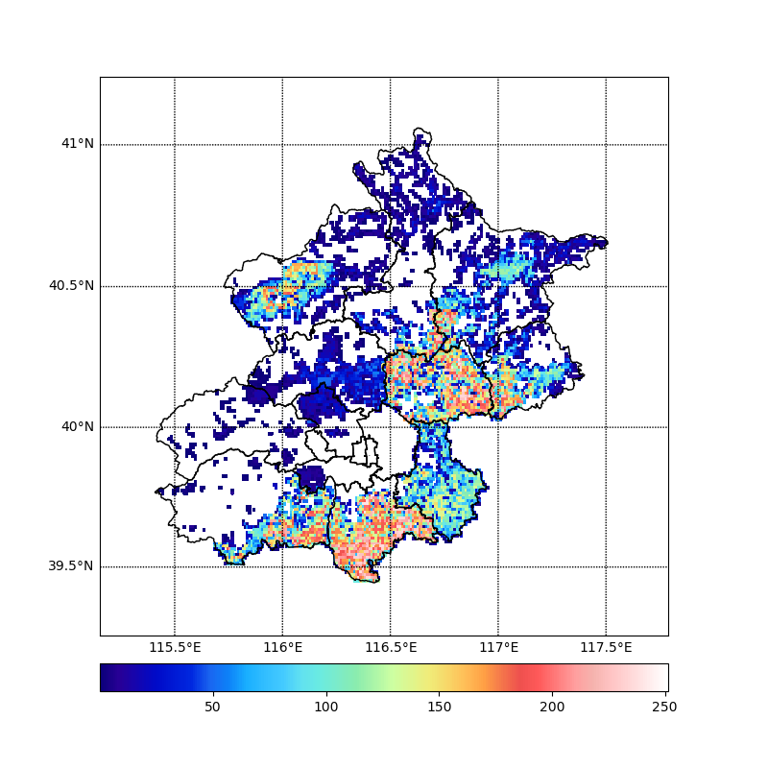

Figure 2 Food crop productivity of 1km * 1km zoning grids in Beijing, 2015 (Mg)

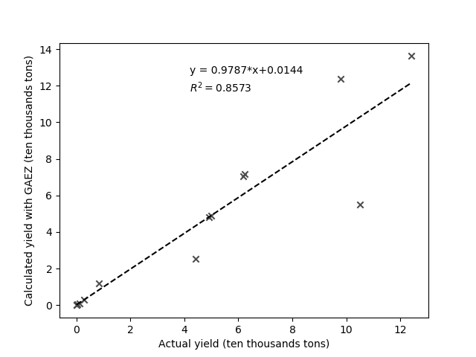

Figure 3 Validating results of the food productivity estimated with GAEZ model at the county level of Beijing

## 3.2 Carbon sequestration potential estimating of agricultural afforestation

The effects of agricultural afforestation on carbon holding capacity is estimated as the sum of the carbon sequestration of plant biomass and the change of SOC of topsoil (0-20cm) after afforestation (Eq. 1).

(2)

where represents the carbon sequestration increase of above-ground biomass (Liu et al., 2014). represents the SOC change of below-ground soil (0 - 20 cm).

According to the assessment of carbon carry capacity of mature forest biomass in China, the carbon sequestration increase of plant biomass (, Mg C/ha) is estimated based on the spatial heterogeneity of mean annual precipitation (, mm) and mean annual temperature (, ℃) (Eq. 2) (Liu et al., 2014).

(3)

In this research, we assumed that the SOC level of topsoil could reach the saturation level of soil after afforestation. The carbon sequestration increase of topsoil is estimated as the difference of current SOC level () and the SOC saturation level () (Eq. 4). The SOC saturation level is estimated based on the dynamic factors of annual temperature (, ℃), annual precipitation (, 100 mm), soil clay content (, %), and soil pH () of agricultural land *j* in the zoning grid. These factors can influence the carbon balance and determine the maximum carbon sequestration potential of soil (Qin and Huang, 2010; Yao and Kong, 2018).

(4)

(5)

(6)

where D represents the soil depth (0-20 cm); represents the existing SOC concentration (g C/kg) in the corresponded depth of soil. andrepresent the soil bulk density (g/cm3) and soil grave content in different soil depth.

The total SOC sequestration potential of topsoil (0 - 20 cm) was estimated as 3.82 Tg C, and the total carbon sequestration potential of plant biomass was estimated as 55.58 Tg C. The estimated carbon sequestration potential of soil of agricultural afforestation is smaller compared with the estimated carbon accumulated potential of plant biomass, which is similar to other studies (Paul et al., 2002). Zoning grids with high value of carbon sequestration potential locate on the south and east of this region, where is also the high value area of food productivity (Figure 4, 5).

Figure 4 Carbon sequestration potential of agricultural afforestation in Beijing, 2015 (A: SOC content of current agricultural soil; B: estimated SOC level after agricultural afforestation; C: carbon sequestration potential of plant biomass after agricultural afforestation; D: total carbon sequestration potential after agricultural afforestation; all data were estimated based on 1km * 1km grids and the soil depth is 0 - 20 cm; unit: Gg C)

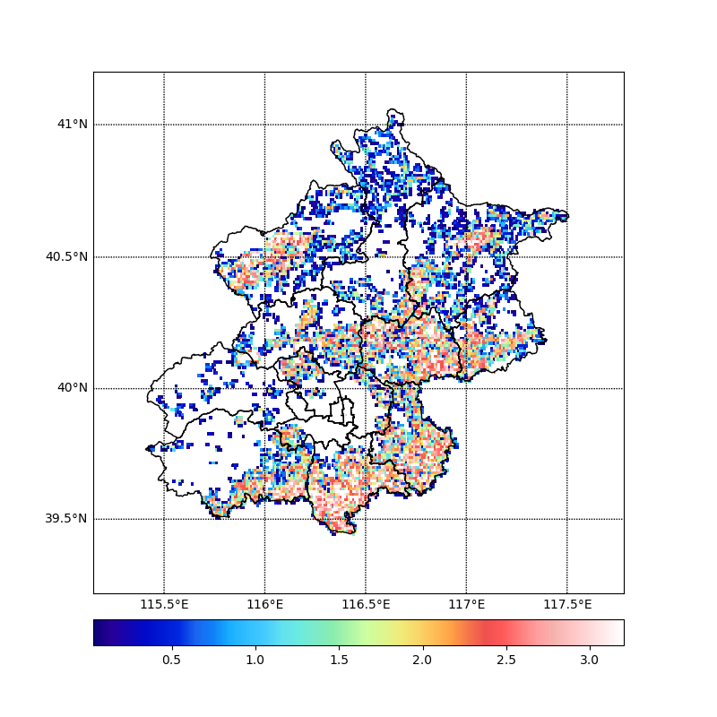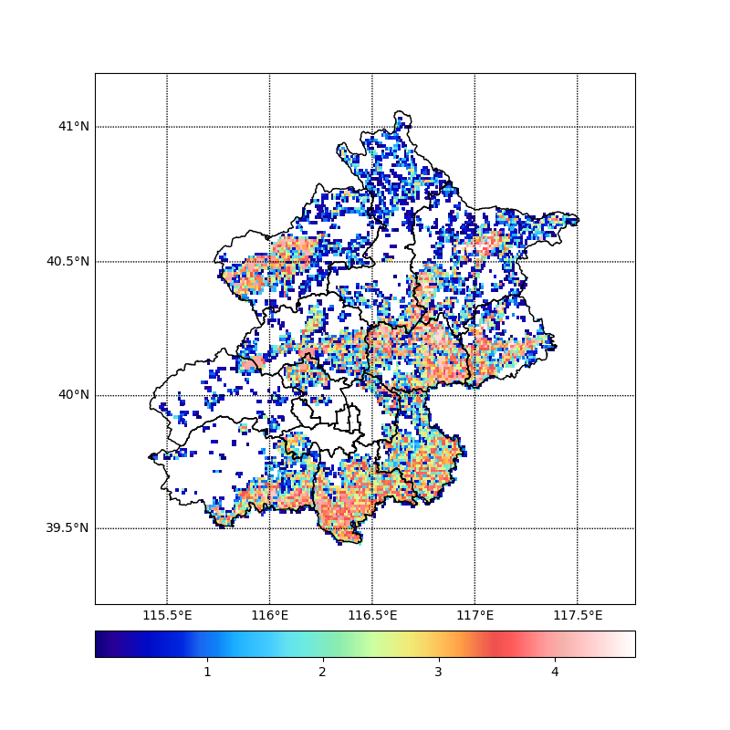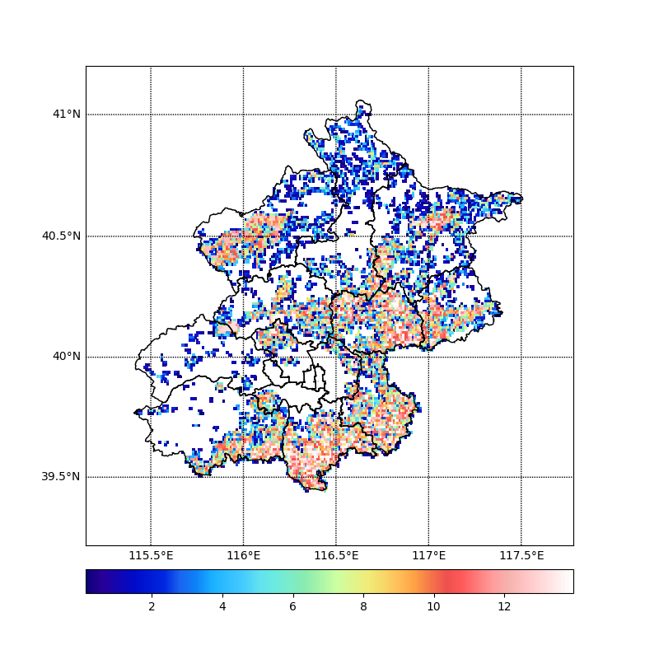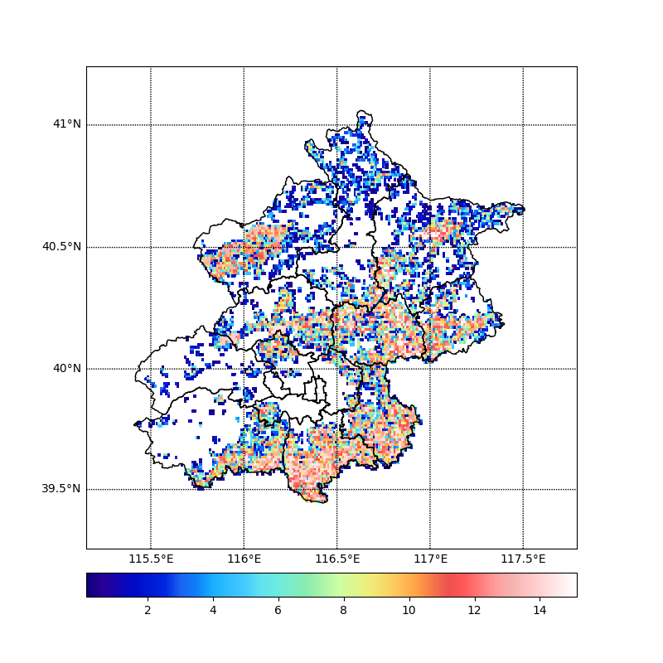

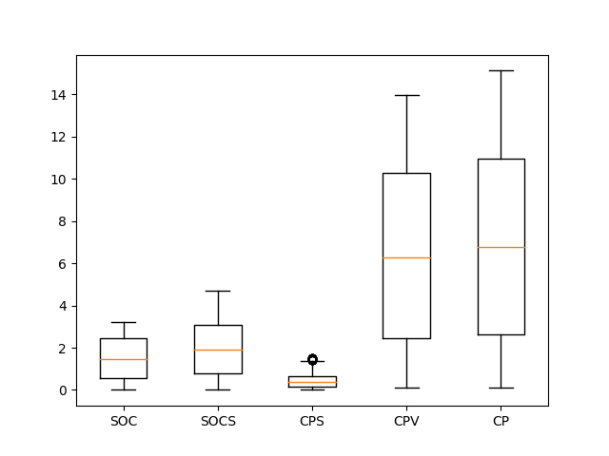

Figure 5 Carbon sequestration potential of agricultural afforestation (SOC: current SOC level; SOCS: SOC saturation level of agricultural grids; CPS: SOC sequestration potential of topsoil (0 – 20 cm). CPV: carbon sequestration potential of plant biomass; CP: total carbon sequestration potential of agricultural afforestation; values are calculated based on the 1km * 1km grids; unit: Gg C)

## 3.3 Formulating of particle swarm model

In this research, we assume that particles are located in a multi-dimension space, the dimension number is equal to the number of zoning grids and each dimension is corresponded to a grid. Dimensions are adjacent or neighbored to each other if their corresponded grids are adjacent or neighbored to each other. The position in each dimension is a *True/False* value representing whether the grid corresponded with this dimension is assigned to afforestation zone. Particles are initialized with a random position and will move to change their position to maximize their adaptive value. The adaptive value of particles (*P*) is calculated based on the carbon sequestration potential rate (*CPR*), spatial compactness (*SC*), and food decrease rate (*FDR*) of their position (Eq. 7 - 10). Particles will change their positions step by step until the optimal position is found or the maximum step is reached.

(7)

(8)

(9)

(10)

where represents the afforestation coefficient which is equal to 1 when the 1km * 1km zoning grid (i) corresponded to one dimension of particles is assigned to the afforestation area and equal to 0 when it is not. , represent the carbon sequestration potential and the food productivity of the grid, respectively. represents the maximum food decrease rate coming from scenario settings; , represent the total number and number with same position value in the adjacent dimensions of dimension i, respectively.

Each step, some dimensions of particles would be randomly selected. The particle would change its position at the selected dimension and its neighbor dimensions (Eq. 11).

(11)

where represents the position of the particle at the dimension (*p*) and its neighbor dimensions. Random (0,1) represents that the particle would change its position at these dimensions to a random position value; represents that the particle would change its position to the same position value of the historical optimized state of this particle; represents that the particle would change its position at these dimensions to the same position of the optimized state in all particles; a, b, and c represent the self-conscious coefficient, cognitive coefficient, and social coefficient of particles, respectively; r represents the random number between 0 and the sum of a, b, and c. In order to improve the performance of the model, the self-conscious value will decrease following with the iteration steps, which is a common technic used in PSO models (Parsopoulos and Vrahatis, 2007).

## 3.3 Optimization of afforestation areas with multi-scenarios

Multi-scenarios were conducted where the spatial compactness weights were set from 0.5 to 4 and the food decrease rates were set from 0.05 to 0.3 (totally 30 scenarios, figure 6). The optimized carbon sequestration potential under different scenarios were simulated with the particle swarm model. 50 particles were initialized in each simulation scenario and the maximum step is setting as 3000. The global optimized position found by the particle swarm were extracted to represent the optimized results of agricultural afforestation zone under different scenarios (Figure 6 - 8).

The increased carbon sequestration potentials in the optimization results are significant higher than the loss of food productivity, for example, 8.80 -12.47 Tg C (14.82 – 20.93 % of the maximum carbon sequestration potential with different spatial compactness weight settings) can be sequestrated with 5% loss of current food productivity; 27.58 – 29.94 Tg C (46.43 – 50.40 % of the maximum carbon sequestration potential with different spatial compactness weight settings) can be sequestrated with 30 % loss of current food productivity (Figure 6). The optimized carbon sequestration potential of agricultural afforestation is negatively related with both the increase of spatial compactness weights and the decrease of FDR. Based on the FDR and spatial compactness setting ranges in this research, the influence of spatial compactness weights would be more significant when the FDR is low than it is high.

The setting of spatial compactness weights can also significantly influence the spatial distribution of optimized agricultural afforestation area (Figure 7). The higher setting of spatial compactness weights will shape the afforestation area more compactness with the cost to decrease the afforestation grids in some zones (Figure 7). The spatial distribution of optimized afforestation is also highly influenced by the change of food decrease rate since the more afforestation grids will appear with the higher value of food decrease rate (less restriction of food security) and vice versa.

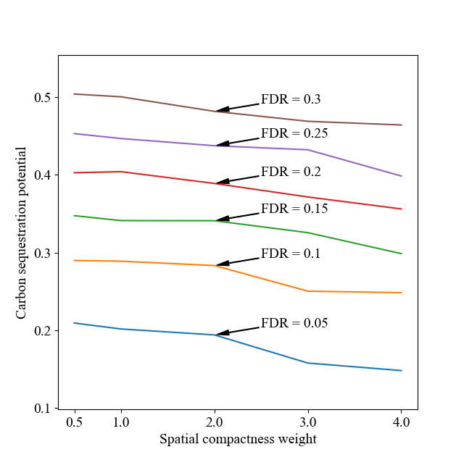

Figure 6 Carbon sequestration potential of agricultural with different scenarios (FDR: food decrease rate; Carbon sequestration potential represents the ratio of the maximum carbon sequestration potential (59.40 Tg C))

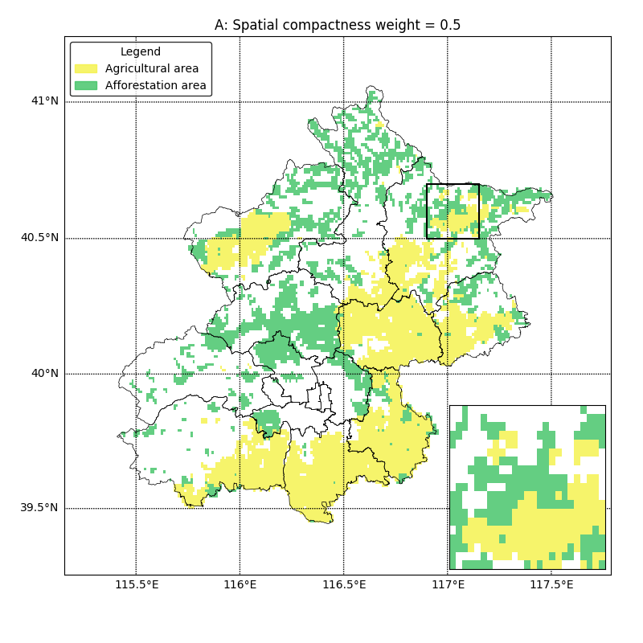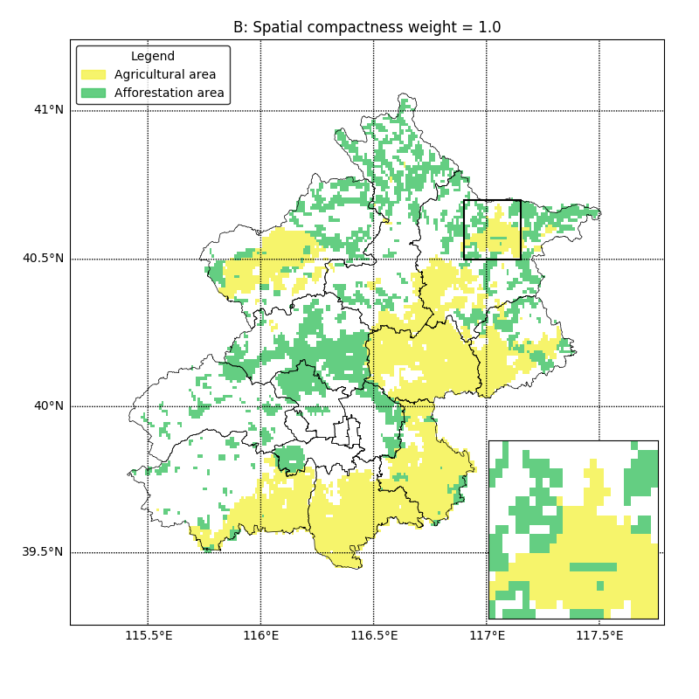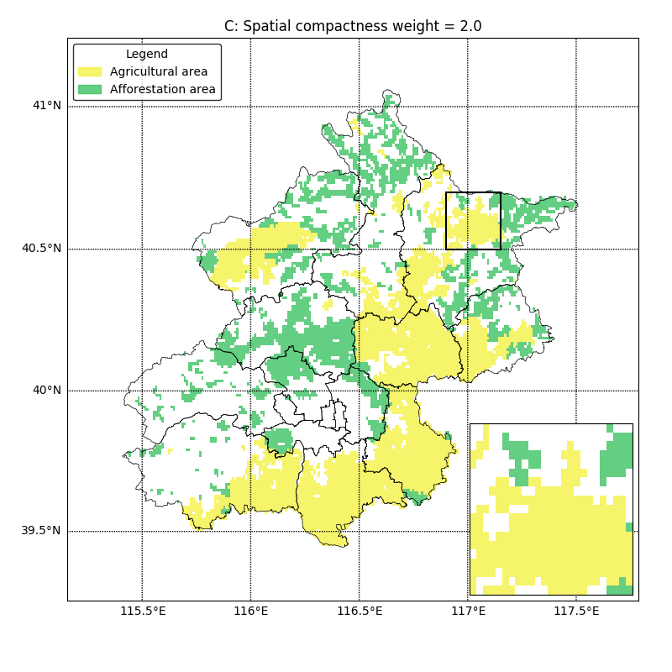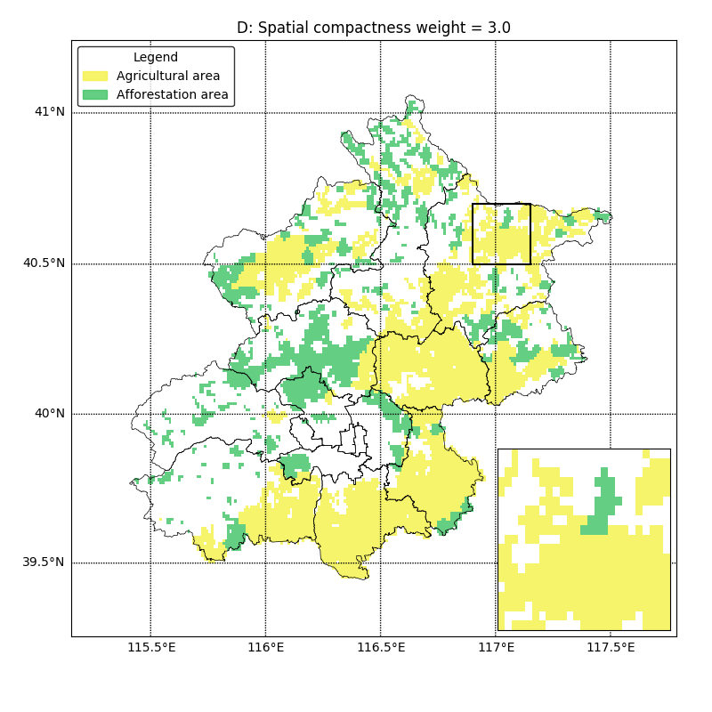

Figure 7 Optimized zoning of agricultural afforestation with different spatial compactness weights (Food decrease rate = 0.1)

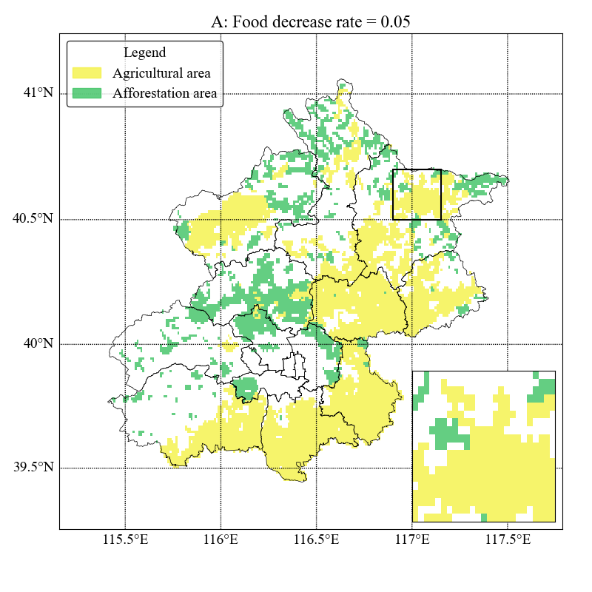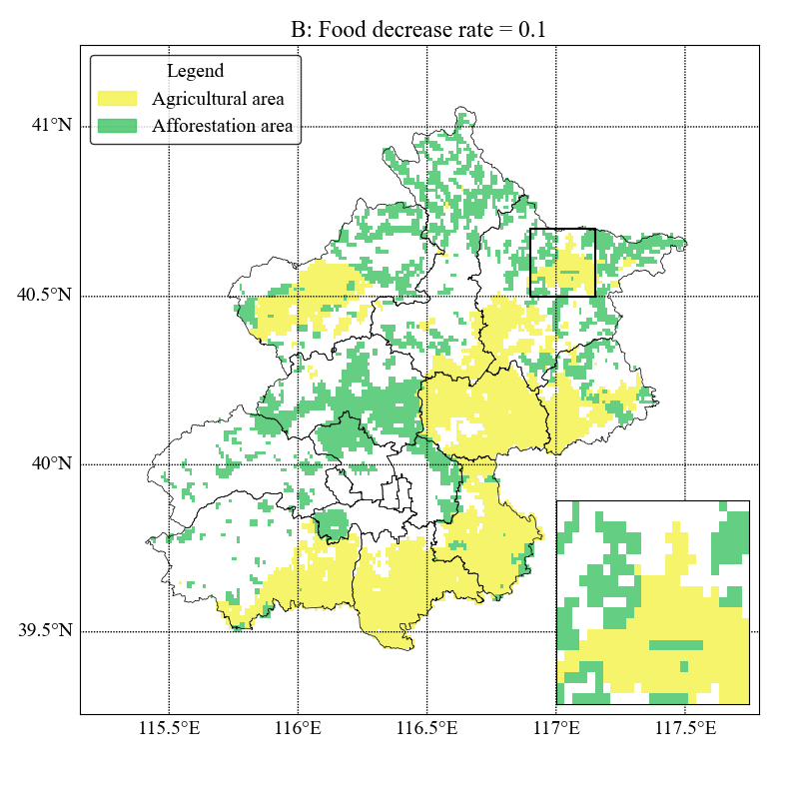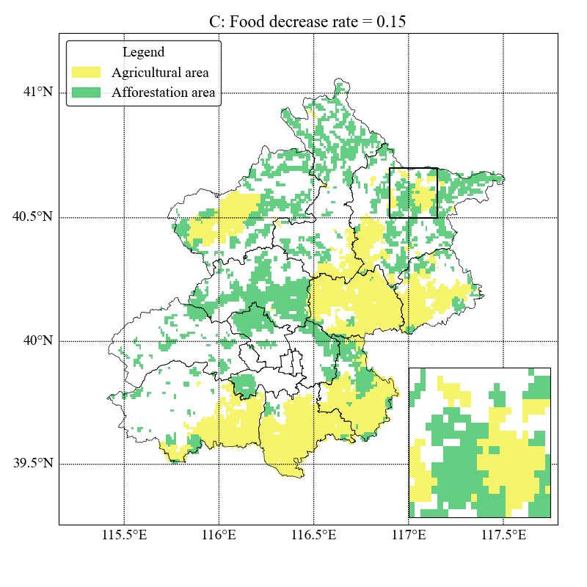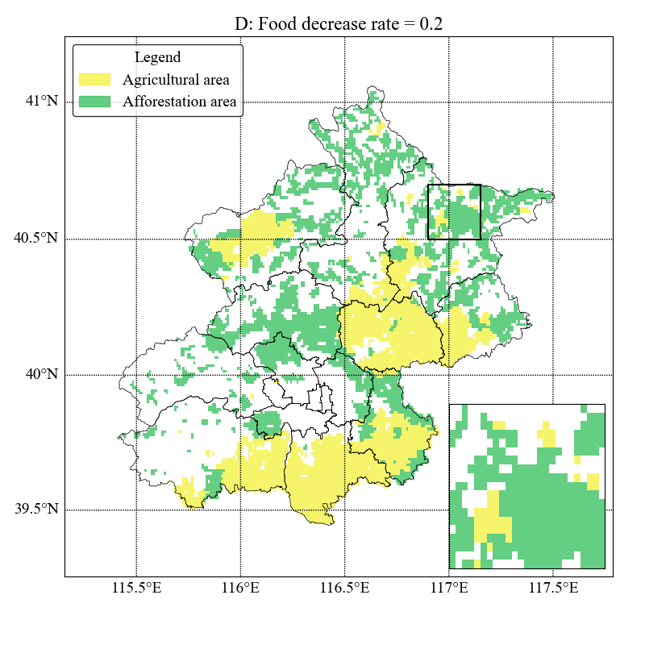

Figure 8 Optimized zoning of agricultural afforestation with different food decrease rates (Spatial compactness weight = 1)

# 4 Discussion

In this research, we proposed a PSO method to simulate the optimized zoning of agricultural afforestation area and estimate the carbon sequestration potential of agricultural afforestation under the restriction of food security. This method is different with traditional method in related studies which focus on estimating the carbon sequestration potential of afforestation of marginal agricultural land (usually with small area) (Niu and Duiker, 2006). The definition of marginal agricultural land is a little fuzzy in these studies which will render uncertainty to the estimation. On the other hand, either the afforestation of marginal land with higher productive ability or the missing of non-marginal land with lower productive ability is not wise enough to estimate the carbon sequestration potential of agricultural afforestation. It is necessary considering the spatial heterogeneity of agricultural productivity to determine where to conduct the afforestation program. The major challenge of agricultural afforestation lies in the balance of the loses of agricultural productivity and the gains of carbon sequestration potential. Estimating the carbon sequestration of agricultural afforestation is an optimization problem with multi objective to maximum the gains of carbon sequestration potential and minimize the loses of food productivity. Moreover, the utility of spatial distribution should also be considered in this problem since the spatial distribution will influence the afforestation effect. It is acknowledged that the higher compactness of the optimization results can both do positive effect to the agricultural productivity and the management of afforestation program.

In order to address the multi-objective problem, we employed the PSO method to find the optimized distribution of agricultural afforestation area. The particles in this model are assumed to live in a multi dimension world and the zoning results of land use grids is encoded as the position of particles. The optimized position can be achieved by particles through the competition and corporation of particles. This formulation is different with traditional PSO formulation wherein particles are always assumed to move in a less dimension world (usually two or three dimensions) (Shi, 2001). Meanwhile, we formulated that the particle position at each dimension is a True/False value representing whether the related grid is assigned as an afforestation grid. This assumption can reduce the complexity of the PSO model to avoid the under fitting of the model. Results has been demonstrated that our formulation of the PSO model is effective in solve the optimization problem of agricultural afforestation and it is also sensitive with the change of objective settings.

The treatment of food security objective in this research is also different with tradition approaches wherein the technical of weights setting are commonly used to represent the importance heterogeneity of different objectives. The hard restriction of maximum food decrease rate is used in this research to represent the importance of food security. This treatment can not only reduce the technic uncertainty of weight setting, but also provide more practical results to guide land use planning at regional scale. The food security objective or the demand of food productivity is always a hard restriction in real world which is directly determined by the population, consumption, technology, and trading. The pursuit of carbon sequestration should be built on the basis of the restriction of food security. The treatment of food decrease rate as a hard restriction instead a weighted objective can represent the difference of food security and other objectives in the real world.

The major limitation and uncertainties of this research come from the spatial estimation of food productivity and carbon sequestration potential. We estimated the spatial food productivity based on the GAEZ model and modified the food production capacity with land use maps and statistic data. This estimating shows acceptable accuracy caparison with the statistic results at regional scale (Figure 3). However, the performance of this estimation at grid scale is still unclear, which will increase the uncertainty of determining the afforestation area at grid scale. This limitation can be solved with the formed data collection of food productivity at local scale and the high-resolution interpretation of cultivation pattern distribution maps. The estimation uncertainty of carbon sequestration potential comes from both the data uncertainty and the approach uncertainty. Although the mechanism of carbon sequestration of soil and plant has achieved significant success in the early year in this century (Belyea and Malmer, 2004; Blanco-Canqui and Lal, 2004; Ramachandran Nair et al., 2009). Estimating the carbon sequestration potential at regional/global scale is still challenging and un-uniform with different studies due to the lack of uniform data collection and the parameter setting of employed approaches (Falloon et al., 2002). In this research, we employed dynamic statistic models to estimate the carbon sequestration potential of soil plant based on the spatial heterogeneity of temperature, precipitation, height, soil properties, etc. The advantage of using the statistic model is that the spatial heterogeneity of carbon sequestration potential at regional scale can be estimated with easy-collected data and few setting of parameters. However, it will also lead to high uncertainty for the estimating results. More mechanism model, such as the DNDC model to estimate the carbon sequestration of soil and the CO2FIX model (Schelhaas et al., 2004) to estimate the carbon sequestration of plant, should be uemployed in future studies to improve the estimation accuracy of this research.

Despite the afforestation of agricultural land, the afforestation of built-up land should also be taken into consideration in future studies. The reconstruction of built-up land distribution can not only contribute to the urbanization process, but also provide an opportunity to restore/improve the ecological function of territorial system. For example, in China, while the primary objective of built-up land reclamation in the early years of this century is to increase the farmland area and improve the food productivity, this objective has changed nowadays, more and more derelict buildings were primarily afforested to forest land instead of agricultural land to increase the carbon holding capacity and improve the ecosystem functions. The reclamation of built-up land is also become a multi-objective and spatial heterogeneity problem. It is also expected to address this problem with the implication of similar artificial intelligence method.

The successful implication of PSO in this research and other related studies (Liu et al., 2013; Yaolin Liu et al., 2012) also shows the high potential of artificial intelligence methods in land use planning. Artificial intelligence, including swarm intelligence, artificial neural networks, fuzzy models, cellular automata, genetic algorithms, hybrid systems, reinforcement learning and deep learning (Chen et al., 2008) are become more and more important in recent years not only in the study of computer science, but also in many other studies, such as transportation (Kannan et al., 2017), medicine (Hamet and Tremblay, 2017), etc. It can be expected that the implication of artificial intelligence method in land use planning can render the art of land use planning to science to decrease the uncertainty of land use planning and contribute to the alternative generating of land use patterns.

# 5 Conclusion

Agricultural afforestation is an efficiency and easy managed way to sequestrate the carbon dioxide in atmosphere system to organic carbon in territorial system. It is also the most favorable way to meet the commitments of carbon reduction (Falloon et al., 2002). It is also challenging to determine the spatial distribution of agricultural afforestation area and estimate the carbon sequestration potential since the restriction of food security must be considered. The spatial heterogeneity of both food productivity and carbon holding capacity further complex this challenge.

In this research, we proposed a PSO method to estimate the carbon sequestration potential of agricultural afforestation under the restriction of food security and the consideration of spatial compactness. In order to represent the spatial heterogeneity of food productivity and carbon holding capacity, we first estimated the spatial food productivity potential with GAEZ model and the maximum carbon sequestration potential of agricultural afforestation without the restriction of food security. Then the PSO method was formulated and applied to simulate the optimized spatial distribution of agricultural afforestation area and estimate the carbon sequestration potential under different scenarios in Beijing, China. Results shows that 1) the maximum carbon sequestration potential of agricultural afforestation in Beijing can reach 59.40 Tg C without where all the agricultural land were afforested; 2) both the restriction of food security and consideration of spatial compactness can affect the optimized spatial distribution and the carbon sequestration potential of agricultural afforestation; 3) the influence of spatial compactness is different with different food security restriction. It can be concluded that the method proposed in this research can be used to simulate the optimized distribution of agricultural afforestation area and estimate the carbon sequestration potential of agricultural afforestation under the restriction of food security and the consideration of spatial compactness. This method can also be used in other regions and help planners to compare the gains and costs of agricultural afforestation area under different scenarios and find the utility agricultural afforestation planning under the restriction of food security and consideration of spatial compactness. This research can also inform the study of land use planning focusing on the implication of artificial intelligent method to generate alternative land use patterns.

**Acknowledgements:** This research is funded by the Beijing Natural Science Foundation (Project No. 8151001) and the China Scholarship Council. The source code and the animation of the optimization process can be found on the <https://github.com/YaoJT/Land_use-optimization/tree/master/agricultural_afforestation>.

# References

Andres, R.J., Gregg, J.S., Losey, L., Marland, G., Boden, T.A., 2011. Monthly, global emissions of carbon dioxide from fossil fuel consumption. Tellus B 63, 309–327. https://doi.org/10.1111/j.1600-0889.2011.00530.x

Belyea, L.R., Malmer, N., 2004. Carbon sequestration in peatland: patterns and mechanisms of response to climate change. Glob. Change Biol. 10, 1043–1052.

Beyer, S., 2006. The Green Olympic Movement: Beijing 2008. Chin. J. Int. Law 5, 423–440.

Blanco-Canqui, H., Lal, R., 2004. Mechanisms of carbon sequestration in soil aggregates. Crit. Rev. Plant Sci. 23, 481–504.

Chang, R., Jin, T., Lü, Y., Liu, G., Fu, B., 2014. Soil Carbon and Nitrogen Changes following Afforestation of Marginal Cropland across a Precipitation Gradient in Loess Plateau of China. PLoS ONE 9. https://doi.org/10.1371/journal.pone.0085426

Chen, S.H., Jakeman, A.J., Norton, J.P., 2008. Artificial Intelligence techniques: An introduction to their use for modelling environmental systems. Math. Comput. Simul., Special Issue: Selected Papers of the MSSANZ/IMACS 16th Biennial Conference on Modelling and Simulation, Melbourne, Australia, 12-15 December 2005 78, 379–400. https://doi.org/10.1016/j.matcom.2008.01.028

Chenfang, L., Linxiu, Z., Shengen, F., 2002. A Study on the Factors Affecting Farmer’s Agricultural Production Investment [J]. China Rural Surv. 4, 005.

Deng, L., Wang, K., Tang, Z., Shangguan, Z., 2016. Soil organic carbon dynamics following natural vegetation restoration: Evidence from stable carbon isotopes (δ13C). Agric. Ecosyst. Environ. 221, 235–244. https://doi.org/10.1016/j.agee.2016.01.048

Eberhart, R., Kennedy, J., 1995. A new optimizer using particle swarm theory, in: Micro Machine and Human Science, 1995. MHS’95., Proceedings of the Sixth International Symposium On. IEEE, pp. 39–43.

Falloon, P., Smith, P., Szabo, J., Pasztor, L., 2002. Comparison of approaches for estimating carbon sequestration at the regional scale. Soil Use Manag. 18, 164–174.

Fischer, G., Nachtergaele, F.O., Prieler, S., Teixeira, E., Tóth, G., Van Velthuizen, H., Verelst, L., Wiberg, D., 2012. Global Agro-ecological Zones (GAEZ v3. 0)-Model Documentation.

Fischer, G., Van Velthuizen, H.T., Shah, M.M., Nachtergaele, F.O., 2002. Global agro-ecological assessment for agriculture in the 21st century: methodology and results.

Franks, J.R., Hadingham, B., 2012. Reducing greenhouse gas emissions from agriculture: avoiding trivial solutions to a global problem. Land Use Policy 29, 727–736.

Hamet, P., Tremblay, J., 2017. Artificial intelligence in medicine. Metab.-Clin. Exp. 69, S36–S40.

IPCC Climate Change, 2014. Mitigation of Climate Change. Contribution of Working Group III to the Fifth Assessment Report of the Intergovernmental Panel on Climate Change. Camb. Univ. Press Camb. UK N. Y. NY.

Jiyuan, L., Mingliang, L., Xiangzheng, D., Dafang, Z., Zengxiang, Z., Di, L., 2002. The land use and land cover change database and its relative studies in China. J. Geogr. Sci. 12, 275–282. https://doi.org/10.1007/BF02837545

Kane, D., Solutions, L.L.C., 2015. Carbon sequestration potential on agricultural lands: A review of current science and available practices. Natl. Sustain. Agric. Coalit. Wash. DC USA.

Kannan, J.R., Rai, A., Szpytko, J., Pandya, Y.C., 2017. Project Zeus : video based behavioural modelling of non-linear transportation system for improved planning &urban construction projects. J. KONES Vol. 24, No. 4. https://doi.org/10.5604/01.3001.0010.3152

Laganière, J., Angers, D.A., Paré, D., 2010. Carbon accumulation in agricultural soils after afforestation: a meta-analysis. Glob. Change Biol. 16, 439–453. https://doi.org/10.1111/j.1365-2486.2009.01930.x

Lal, R., 2004. Carbon emission from farm operations. Environ. Int. 30, 981–90.

Lal, R., 2004. Soil carbon sequestration to mitigate climate change. Geoderma 123, 1–22.

Liu, X., Ou, J., Li, X., Ai, B., 2013. Combining system dynamics and hybrid particle swarm optimization for land use allocation. Ecol. Model. 257, 11–24. https://doi.org/10.1016/j.ecolmodel.2013.02.027

Liu, Y., Liu, D., Liu, Y., He, J., Jiao, L., Chen, Y., Hong, X., 2012. Rural land use spatial allocation in the semiarid loess hilly area in China: Using a Particle Swarm Optimization model equipped with multi-objective optimization techniques. Sci. China Earth Sci. 55, 1166–1177. https://doi.org/10.1007/s11430-011-4347-2

Liu, Y., Tang, W., He, J., Liu, Y., Ai, T., Liu, D., 2015. A land-use spatial optimization model based on genetic optimization and game theory. Comput. Environ. Urban Syst. 49, 1–14. https://doi.org/10.1016/j.compenvurbsys.2014.09.002

Liu, Y., Wang, H., Ji, Y., Liu, Z., Zhao, X., 2012. Land Use Zoning at the County Level Based on a Multi-Objective Particle Swarm Optimization Algorithm: A Case Study from Yicheng, China. Int. J. Environ. Res. Public. Health 9, 2801–2826. https://doi.org/10.3390/ijerph9082801

Liu, Y., Yu, G., Wang, Q., Zhang, Y., Xu, Z., 2014. Carbon carry capacity and carbon sequestration potential in China based on an integrated analysis of mature forest biomass. Sci. China Life Sci. 57, 1218–1229.

Masoomi, Z., Mesgari, M.S., Hamrah, M., 2013. Allocation of urban land uses by Multi-Objective Particle Swarm Optimization algorithm. Int. J. Geogr. Inf. Sci. 27, 542–566. https://doi.org/10.1080/13658816.2012.698016

Morari, F., Lugato, E., Berti, A., Giardini, L., 2006. Long-term effects of recommended management practices on soil carbon changes and sequestration in north-eastern Italy. Soil Use Manag. 22, 71–81.

Nachtergaele, F., van Velthuizen, H., Verelst, L., Batjes, N., Dijkshoorn, K., van Engelen, V., Fischer, G., Jones, A., Montanarella, L., Petri, M., 2009. Harmonized world soil database. Wagening. ISRIC.

Nave, L.E., Swanston, C.W., Mishra, U., Nadelhoffer, K.J., 2013. Afforestation effects on soil carbon storage in the United States: a synthesis. Soil Sci. Soc. Am. J. 77, 1035–1047.

Nilsson, S., Schopfhauser, W., 1995. The carbon-sequestration potential of a global afforestation program. Clim. Change 30, 267–293. https://doi.org/10.1007/BF01091928

Niu, X., Duiker, S.W., 2006. Carbon sequestration potential by afforestation of marginal agricultural land in the Midwestern U.S. For. Ecol. Manag. 223, 415–427. https://doi.org/10.1016/j.foreco.2005.12.044

Noble, I., Bolin, B., Ravindranath, N.H., Verardo, D.J., Dokken, D.J., 2000. Land use, land use change, and forestry. Cambridge University Press.

Parsopoulos, K.E., Vrahatis, M.N., 2007. Parameter selection and adaptation in unified particle swarm optimization. Math. Comput. Model. 46, 198–213.

Paul, K.I., Polglase, P.J., Nyakuengama, J.G., Khanna, P.K., 2002. Change in soil carbon following afforestation. For. Ecol. Manag. 168, 241–257. https://doi.org/10.1016/S0378-1127(01)00740-X

Plantinga, A.J., Wu, J., 2003. Co-Benefits from Carbon Sequestration in Forests: Evaluating Reductions in Agricultural Externalities from an Afforestation Policy in Wisconsin. Land Econ. 79, 74–85. https://doi.org/10.2307/3147106

Qin, Z., Huang, Y., 2010. Quantification of soil organic carbon sequestration potential in cropland: A model approach. Sci. China Life Sci. 53, 868–884. https://doi.org/10.1007/s11427-010-4023-3

Ramachandran Nair, P.K., Mohan Kumar, B., Nair, V.D., 2009. Agroforestry as a strategy for carbon sequestration. J. Plant Nutr. Soil Sci. 172, 10–23.

Schelhaas, M.J., van Esch, P.W., Groen, T.A., de Jong, B.H.J., Kanninen, M., Liski, J., Masera, O., Mohren, G.M.J., Nabuurs, G.J., Palosuo, T., Pedroni, L., Vallejo, A., Vilen, T., 2004. CO2FIX V 3.1 – A modelling framework for quantifying carbon sequestration in forest ecosystems. ALTERRA, Wageningen, Netherlands.

Shi, S., Han, P., Zhang, P., Ding, F., Ma, C., 2015. The Impact of Afforestation on Soil Organic Carbon Sequestration on the Qinghai Plateau, China. PLoS ONE 10. https://doi.org/10.1371/journal.pone.0116591

Shi, Y., 2001. Particle swarm optimization: developments, applications and resources, in: Evolutionary Computation, 2001. Proceedings of the 2001 Congress On. IEEE, pp. 81–86.

Tilman, D., Balzer, C., Hill, J., Befort, B.L., 2011. Global food demand and the sustainable intensification of agriculture. Proc. Natl. Acad. Sci. 108, 20260–20264.

Woodwell, G.M., Hobbie, J.E., Houghton, R.A., Melillo, J.M., Moore, B., Peterson, B.J., Shaver, G.R., 1983. Global Deforestation: Contribution to Atmospheric Carbon Dioxide. Science 222, 1081–1086. https://doi.org/10.1126/science.222.4628.1081

Wu, Q., Li, H., Wang, R., Paulussen, J., He, Y., Wang, M., Wang, B., Wang, Z., 2006. Monitoring and predicting land use change in Beijing using remote sensing and GIS. Landsc. Urban Plan. 78, 322–333. https://doi.org/10.1016/j.landurbplan.2005.10.002

Xu, Z., Xu, J., Deng, X., Huang, J., Uchida, E., Rozelle, S., 2006. Grain for Green versus Grain: Conflict between Food Security and Conservation Set-Aside in China. World Dev. 34, 130–148. https://doi.org/10.1016/j.worlddev.2005.08.002

Yang, J., McBride, J., Zhou, J., Sun, Z., 2005. The urban forest in Beijing and its role in air pollution reduction. Urban For. Urban Green. 3, 65–78.

Yao, J., Kong, X., 2018. Modeling the effects of land-use optimization on the soil organic carbon sequestration potential. J. Geogr. Sci. under publication.

Zeng, X., Zhang, W., Liu, X., Cao, J., Shen, H., Zhao, X., Zhang, N., Bai, Y., Yi, M., 2014. Change of soil organic carbon after cropland afforestation in ‘Beijing-Tianjin Sandstorm Source Control’ program area in China. Chin. Geogr. Sci. 24, 461–470. https://doi.org/10.1007/s11769-014-0701-6

Zhou, M., 2015. An interval fuzzy chance-constrained programming model for sustainable urban land-use planning and land use policy analysis. Land Use Policy 42, 479–491. https://doi.org/10.1016/j.landusepol.2014.09.002